As you will see in the image sets below, our script has dynamically adjusted the heading of the images to look at the appropriate left and right side of the street (rather than pulling a random heading, which may not be directed towards the sidewalks).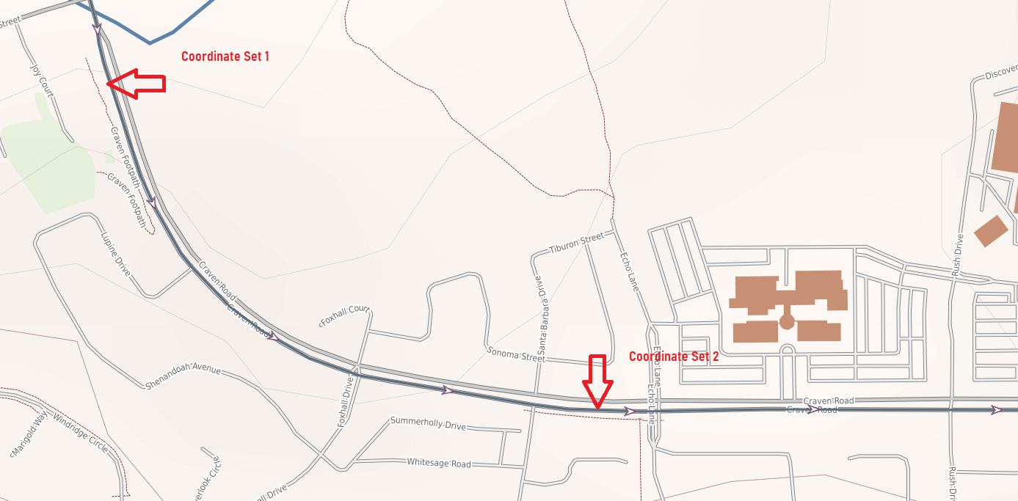

**COORDINATE SET 1**

**Angle 1** ( 33.131572,-117.180281_A1.jpg )

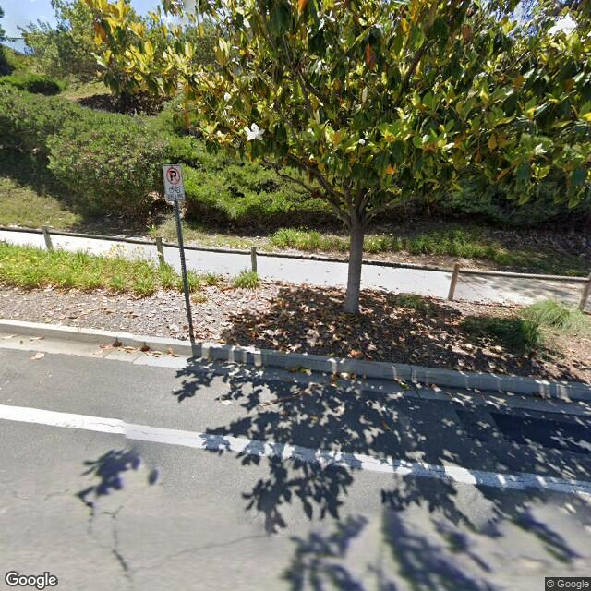

**Angle 2** ( 33.131572,-117.180281_A2.jpg )

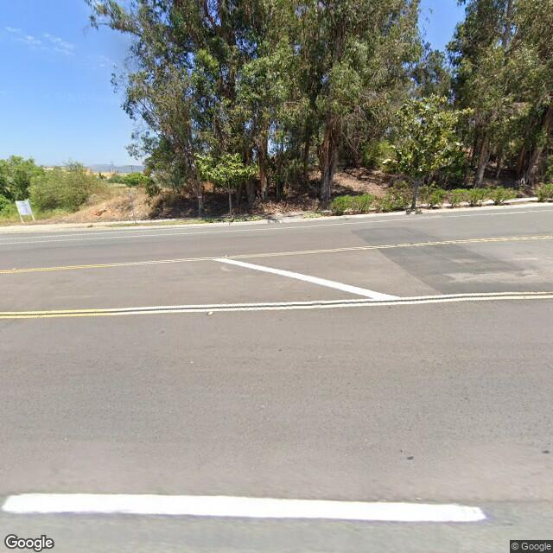

**COORDINATE SET 2**

**Angle 1** ( 33.127333,-117.173499_A1.jpg )

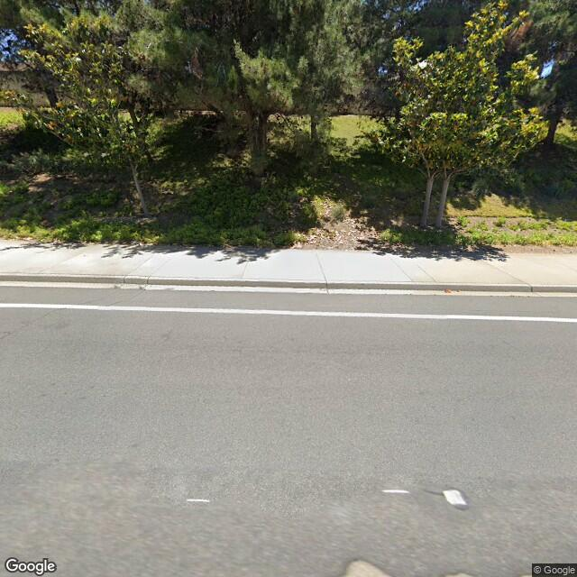

**Angle 2** ( 33.127333,-117.173499_A2.jpg )

